**Assignment 1 (10%)**

COSC 345

22nd April 2020 (Semester 1)

Brittany Duncan: 6805461,

Kayla Montgomery: 3881679,

Makoto McLennan: 3292786,

**Task:**

Deliver a written report on:

What you are going to build, who your anarchists are, how you are going to build it, how long it will take to build, what the establishment already has that your app will do, how your app differs from that, and who you are going to irritate by building it, and why they will be irritated.

**What are we going to build?**

A game in which a player purchases items from a supermarket store. The idea is that a player can only purchase items that have been hard to get during the Covid-19 pandemic, such as pasta, toilet paper, hand sanitiser, and face masks. While ‘shopping’ the player must avoid coming into contact with any of the potentially infected shoppers in the supermarket as many of the non player characters (NPC’s) will be elderly or sick people that follow the player asking for their help. The player will then have to act even more selfishly by avoiding them and only getting what they need to ‘help their own’.

The player in the game will have an unlimited amount of money but a limited amount of time to get the items they require. Once the timer runs out the game will end and a message will appear on the players screen with information about how much they bought from the supermarket/ played the game. There will be a specific message for those players who are greedy and they will be informed of how many people they have disadvantaged because of their greed, or if the player only got equal or below an allocated amount the message would say you only got what was required and they saved food for the vulnerable.

We are going to build a game that has a greater message than just a game that will annoy the player to play it.

**How are you going to build it?**

We will be using Xcode and hopefully publishing the app to the App store later in the year. The underlying code will be written in C and C#, while the art and visual assets will be produced using a variety of resources such as gimp and photoshop.

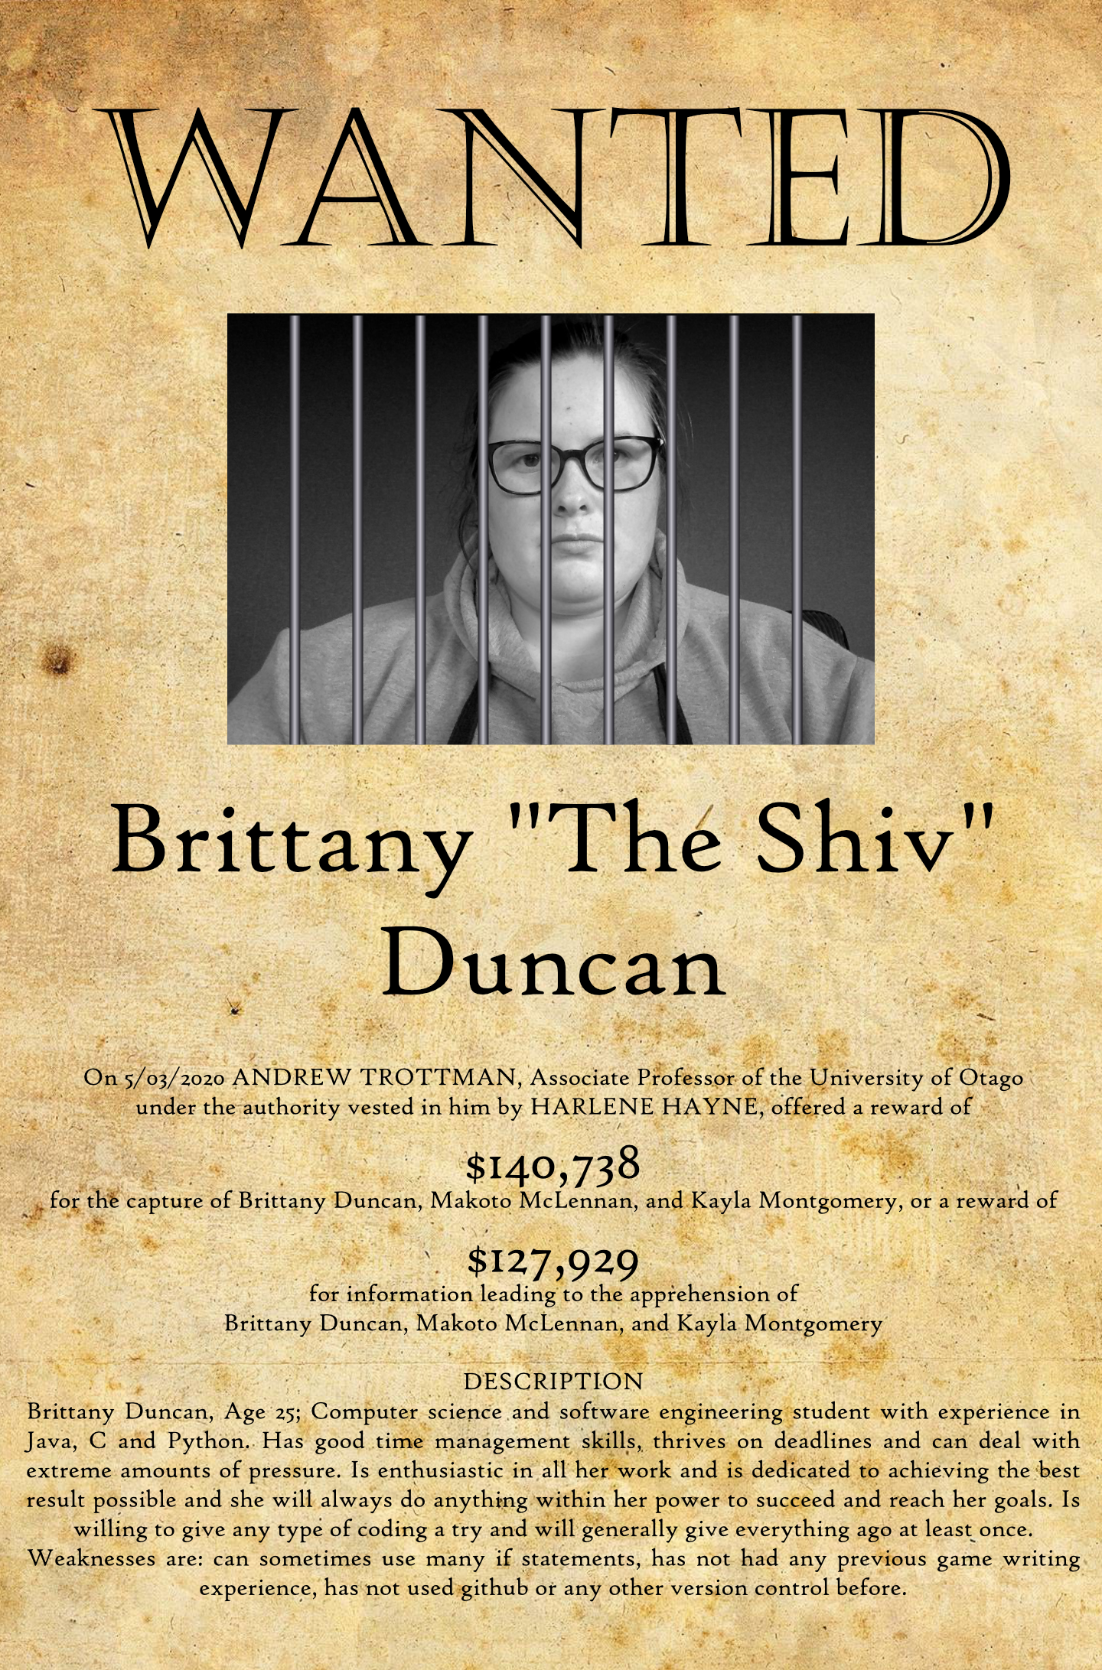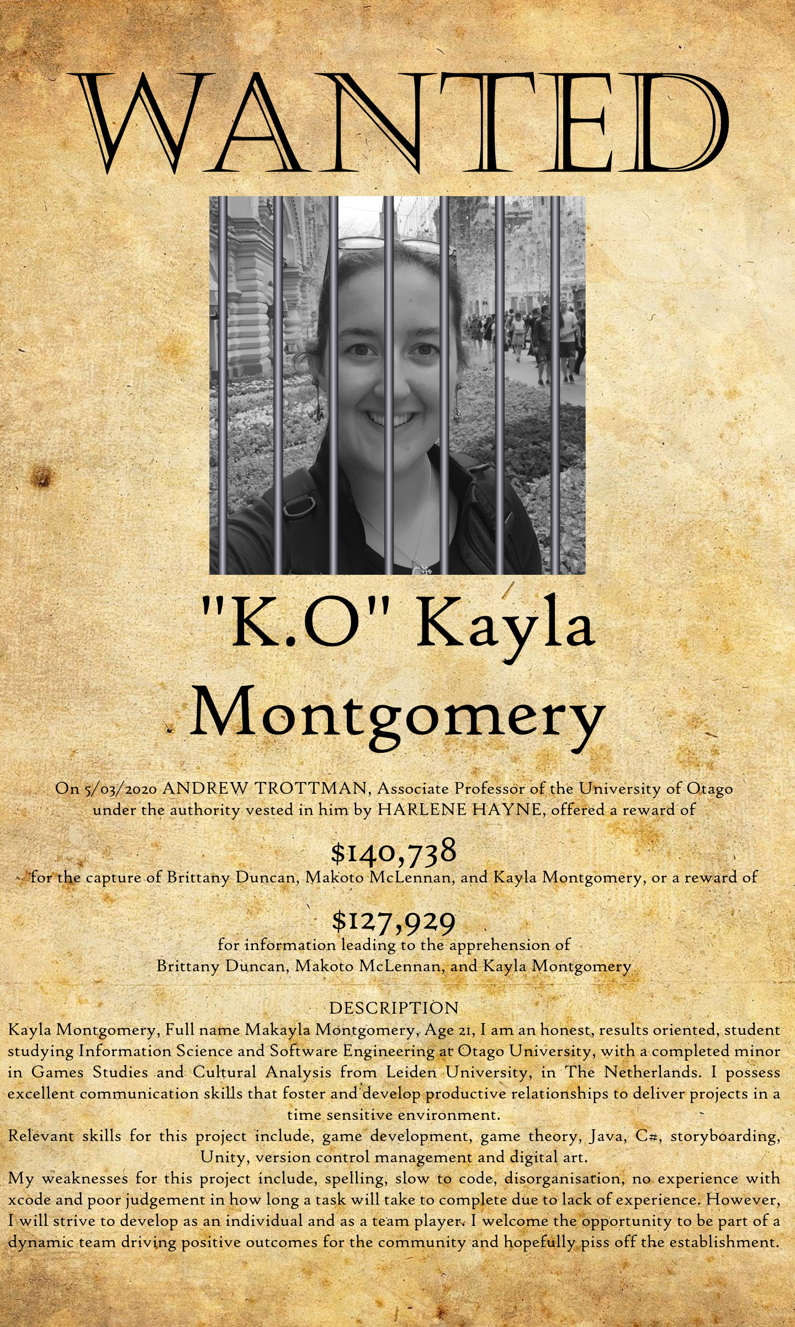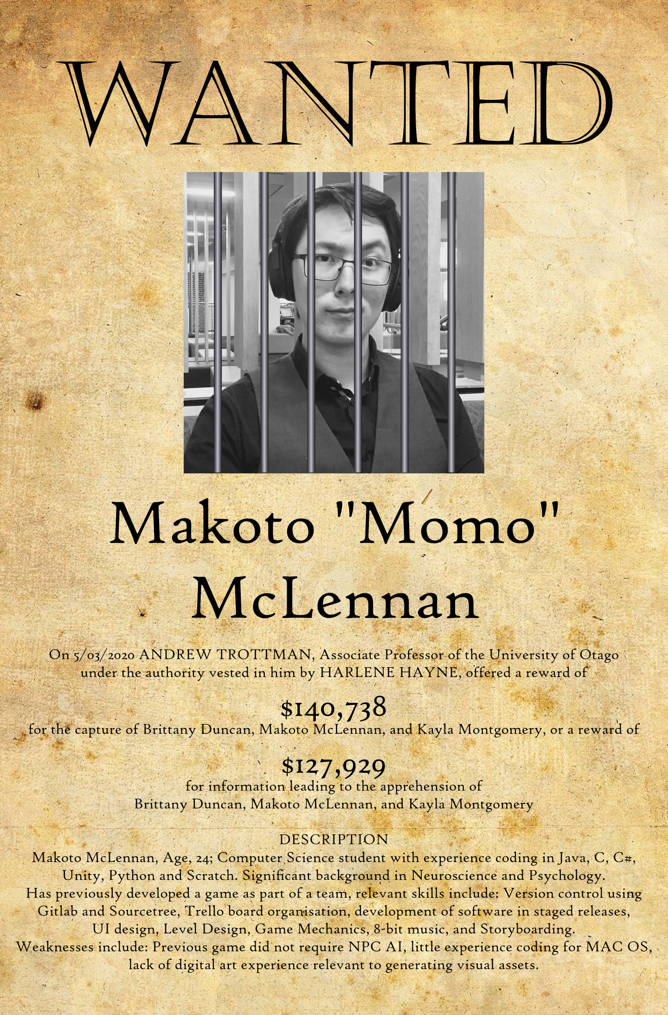

**How long will it take to build?**

The development plan can be broken into 5 rough stages: Planning, Prototyping, Alpha release, Beta release and Full release.

Planning will produce documentation outlining game mechanics, concept, level plans/level design and scope. However, for documenting our planning we will be using Trello which is a post-it note style application that can be used remotely. The Trello board has already been generated and will be updated throughout the project. Trello is an application that takes styles of both Agile and Kan-Ban styles of project planning and design.

Prototyping stage involves testing game mechanics and generating basic concept art. The highest priority prototype will be generating NPC AI/Pathing as we believe this will require the most testing to create a satisfactory mechanic. Prototyping will take place between 24th April and 8th of May.

Alpha release will use placeholders for a large portion of assets. Game mechanics will be working and bug free, but not balanced. Play testing in this stage will be focused on balancing mechanics. Alpha release will be complete on 29 May 2020.

Beta release should contain basic art for key assets, mechanics should be finalised and mostly balanced. Further play testing will be conducted to ensure quality of development. It is in this stage that we will test the reveal of the twist and make necessary changes to ensure maximum guilt. Beta release will be complete on 31st July 2020.

Full release includes finalised art and animation, full playable mechanics and levels. Game should be bug free and balanced. Final release will be completed on 25th September 2020.

**What the establishment has that your app will do and how our app differs from that?**

Our app takes inspiration from existing games both in style and purpose. Our app is similar to a shopping sim game with a “Train” style twist. Players will not be actively encouraged to take large amounts of resources, however the amount they have collected will be displayed. When people play they will assume this to be their score and will try to increase it, just like you would attempt to achieve high scores in normal games. The twist to our game is the higher the player scores the more damage they have done to the rest of society. We wish for the reversal from the norm to cause cognitive dissonance in the player, irritating them and hopefully making them feel guilt at their in game actions. If a player does refrain from raising their score they will be rewarded with a positive message, this will be similar to an easter egg or secret ending found in many games. For instance, multiple titles in the Farcry series can be completed by counter intuitively doing nothing once the main antagonist is introduced leading to the final boss fight taking place at the start of the game instead of the end.

**Who are we going to irritate by building it and why will they be irritated?**

It will irritate the player and hopefully many people not just from playing but hearing about it because so many people have been unable to go to the shop and get essential items during the pandemic especially essential workers and the elderly.

We would also like to target mass media because the words they say, along with their actions have real word consequences for the public.

Our game will be satirical in nature with an underlying message that if you think about your community and not just yourself, there would be less reason to panic. Furthermore, such a mindset would allow for greater trust amongst society and the ability to exhibit empathy towards those less fortunate, ultimately resulting in betterment for all.

During the latest global disaster the Coronavirus (COVID-19) and earlier this year the Australian wildfires, the media did not quell the public's mass panic but incited it. Furthermore, some governments also encouraged such panic, even going as far as to encourage the discrimination of certian communities, cultures and enthicies.

When communities started to panic, it often presented itself in mass buying items from the supermarket and hoarding said stock. These actions, taken by some, disadvantage many others. Those most disadvantaged include those who do not have the capacity to stockpile resources as their access to basic necessities is removed. If people thought about how their actions would affect their community, rather than just looking after themselves, those who are more vulnerable would not need to suffer.

Ultimately we want the irritation caused by our app to provoke the user and make them consider these ideals.

**References:**

<https://fineartamerica.com/featured/dillinger-public-enemy-no-1-wanted-poster-1934-daniel-hagerman.html> John DIllinger wanted poster reference

<https://www.cs.otago.ac.nz/department/staff.php?name=Andrew%20Trotman>

<https://www.gigwise.com/photos/105245/sid-vicious-sex-pistols-quotes-death-anniversary>

Can we pretty please get a bonus 1% for this photo? :D

